**Using a Weighted Scoring Model**

From Schwalbe, *Information Technology Project Management* Ed 7e, Chapter 4

A weighted scoring model is a tool that provides a systematic process for selecting projects based on many criteria. These criteria can include factors such as meeting broad organizational needs; addressing problems, opportunities, or directives; the amount of time needed to complete the project; the overall priority of the project; and projected financial performance of the project.

The first step in creating a weighted scoring model is to identify criteria that are

important to the project selection process. It often takes time to develop and reach agreement on these criteria. Holding facilitated brainstorming sessions or using groupware to exchange ideas can aid in developing these criteria.

Possible criteria for IT projects include:

• Supports key business objectives

• Has strong internal sponsor

• Has strong customer support

• Uses realistic level of technology

• Can be implemented in one year or less

• Provides positive NPV

• Has low risk in meeting scope, time, and cost goals

154

Next, you assign a weight to each criterion based on its importance to the project.

Once again, determining weights requires consultation and final agreement. You can assign weights based on percentages; the weights of the criteria must total 100 percent. You then assign numerical scores to each criterion (for example, 0 to 100) for each project. The scores indicate how much each project meets each criterion. At this point, you can use a spreadsheet application to create a matrix of projects, criteria, weights, and scores.

The example below provides an example of a weighted scoring model to evaluate four different projects.

After assigning weights for the criteria and scores for each project, you calculate a

weighted score for each project by multiplying the weight for each criterion by its score and adding the resulting values.

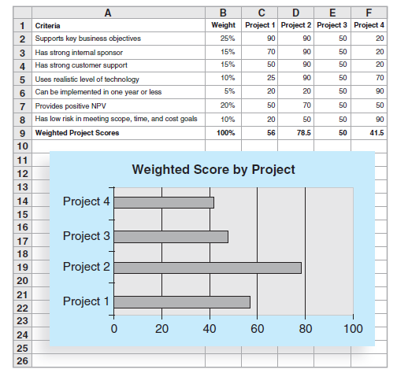

For example, you calculate the weighted score for Project 1 as:

25% * 90 + 15% * 70 + 15% * 50 + 10% * 25 + 5% * 20 + 20% * 50 + 10% * 20 = 56

Note that in this example, Project 2 would be the obvious choice for selection

Because it has the highest weighted score. Creating a bar chart to graph the weighted scores for each project allows you to see the results at a glance. If you create the weighted scoring model in a spreadsheet, you can enter the data, create and copy formulas, and perform a “what-if” analysis.

For example, suppose that you want to change the weights for the criteria.

By having the weighted scoring model in a spreadsheet, you can easily change the

weights to update the weighted scores and charts automatically. This capability allows you to investigate various options for different stakeholders quickly. Ideally, the result should reflect the group’s consensus, and any major disagreements should be documented.

Teachers often use a weighted scoring model to determine grades. For example, suppose that grades for a class are based on two homework assignments and two exams. To calculate final grades, the teacher would assign a weight to each of these items. Suppose Homework One is worth 10 percent of the grade, Homework Two is worth 20 percent, Test One is worth 20 percent, and Test Two is worth 50 percent. Students would want to do well on each of these items, but they should focus on performing well on Test Two because it is 50 percent of the grade.

You can also determine minimum scores or thresholds for specific criteria in a

weighted scoring model. For example, suppose that an organization should not consider a project if it does not score at least 50 out of 100 on every criterion. You can build this type of threshold into the weighted scoring model to reject projects that do not meet these minimum standards.

As you can see, weighted scoring models can aid in project selection

decisions.